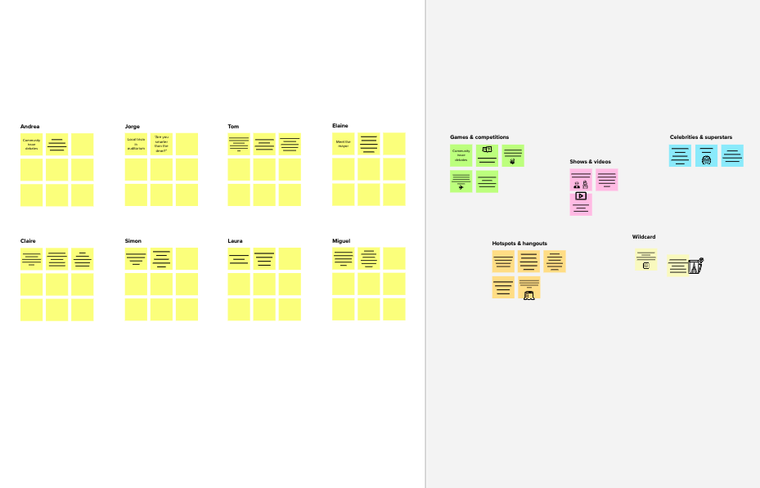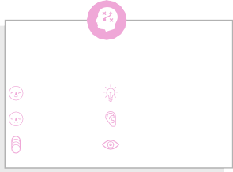

# Brainstorm

**TIP**

You can select a sticky note and hit the pencil [switch to sketch] icon to start drawing!

### Before you collaborate

A little bit of preparation goes a long way with this session. Here’s what you need to do to get going.

**10 minutes**

**1**

### Define your problem statement

What problem are you trying to solve? Frame your problems as a How Might We statement , This will be the focus of your brainstorm.

**5 minutes**

**2**

### Brainstorm

Write down any ideas that come to mind that address your problem statement.

**10 minutes**

**3**

### Group ideas

Take turns sharing your ideas while clustering similar or related notes as you go. Once all sticky notes have been grouped, give each cluster a sentence-like label. If a cluster is bigger than six sticky notes, try and see if you and break it up into smaller sub-groups.

**20 minutes**

**4**

### Prioritize

Your team should all be on the same page about what's important moving forward. Place your ideas on this grid to determine which ideas are important and which are feasible.

**20 minutes**

### After you collaborate

You can export the mural as an image or pdf to share with members of your company who might find it helpful.

**Quick add-ons**

# & idea prioritization

**TIP**

Add customizable tags to sticky notes to make it easier to find, browse, organize, and categorize important ideas as themes within your mural.

Make sure that the platform is easy to use

**PROBLEM**

Many disable person facing difficulties in conversation to normal people. Our project is to built the application which convert the sign

**A Team gathering**

Define who should participate in the session and send an invite. Share relevant information or pre-work ahead.

#### Sabreena Bano

Make UI Get Rid of data

#### Gulshan Ara

people who are in wheel chairs to move their

By creating an app to help people with speech impediments and also stroke affected people temporarily

1. **Share the mural**

**Share a view link** to the mural with stakeholders to keep

Design suitable algorithm for the predictor

Use this template in your own brainstorming sessions so your team can unleash their imagination and start shaping concepts even if you're not sitting in the same room.

1. **Set the goal**

Think about the problem you'll be focusing on solving in the brainstorming session.

1. **Learn how to use the facilitation tools**

Use the Facilitation Superpowers to run a happy and productive session.

language into speech and vice versa

Make a deep research about the user datasets

Get best accuracy for our model

simple for both the user

Boost up the speed of the discussion

redundany that is faced during the model

It should be compactible to all type of user

wheelchair we can attach a module with that which move forward or any direction according to the person facial expression which is determined by computer vision.

using machine learning to get the pattern of speech the people speaks and normalizing their speech.

creating AI based device that assist visually impaired people by voice assissting about the obstacles near them.

**Testing and accuracy Collection of data**

## 

Make sure that the accuracy of the model is also elevated to the greatest degree possible

Ensure that our accuracy is is sufficiently reliable for the users

Make a deep research about the user datasets

Collect various sign languages neat datasets.

Ease of accessibility of data should be maintained throughout

them in the loop about the outcomes of the session.

**B Export the mural**

Export a copy of the mural as a PNG or PDF to attach to emails, include in slides, or save in your drive.

**10 minutes** to prepare

**1 hour** to collaborate

**2-8 people** recommended

[**Open article**](https://support.mural.co/en/articles/2113740-facilitation-superpowers)

Ease of accessibility of data should be maintained throughout

Test our model with various and different datasets.

Discard any unnecessary data, to save make our model faster.

Collect atleast 1000 images for one sign language.

Choose right algorithm for our model

#### Surega A

**Suguna S V**

#### Keep moving forward

**Strategy blueprint**

Define the components of a new idea or strategy.

Get best accuracy for our model

Ensure that the predictor is user friendly

Images should be cleared and accurate

Display a

starting video

Make sure

platform is

Conversion

time should

tutorial for our accessible to be minized

#### Key rules of brainstorming

Our model should convert all type of languages

To run an smooth and productive session

user

create larger

every one.

Walkstick with AI

by our model

**Designing algorithms User's end**

[**Open the template**](https://app.mural.co/template/e95f612a-f72a-4772-bc48-545aaa04e0c9/984865a6-0a96-4472-a48d-47639307b3ca)

dataset which pairs with mobile app

**Customer experience journey map**

Stay in topic. Defer judgment.

Encourage wild ideas. Listen to others.

has related information

will inform about restaurants, obstacles to visually impaired.

Design suitable algorithm for the predictor

Ensure that the predictor is user friendly

Make sure that the platform is easy to use

#### Importance

Make sure that the platform is easy to use

Choose right algorithm for our model

Deploy classification algorithm as and when required.

Use Convolution Neural Network model for our training

Verify our data set and train our model

If each of these tasks could get

Ease of accessibility of data should be maintained throughout

Display a video tutorial on the functioning of the model for the user.

Understand customer needs, motivations, and obstacles for an experience.

[**Open the template**](https://app.mural.co/template/b7114010-3a67-4d63-a51d-6f2cedc9633f/c1b465ab-57af-4624-8faf-ebb312edc0eb)

Display a video tutorial on the functioning of the model for the user.

Go for volume. If possible, be visual.

done without any difficulty or cost, which would have the most positive impact?

**Strengths, weaknesses, opportunities & threats**

Identify strengths, weaknesses, opportunities, and threats (SWOT) to develop a plan.

Make sure that the accuracy of the model is also elevated to the greatest degree possible

[**Open the template**](https://app.mural.co/template/6a062671-89ee-4b76-9409-2603d8b098be/ca270343-1d54-4952-9d8c-fbc303ffd0f2)

**TIP**

Ensure that our accuracy is is sufficiently reliable for the users

Participants can use their cursors to point at where sticky notes should go on the grid. The facilitator can confirm the spot by using the laser pointer holding the **H key** on the keyboard.

[**Share template feedback**](https://muralco.typeform.com/to/CiqaHVat?typeform-source=app.mural.co)

[**Share template feedback**](https://muralco.typeform.com/to/CiqaHVat?typeform-source=app.mural.co)

#### Feasibility

Regardless of their importance, which tasks are more feasible than others? (Cost, time, effort, complexity, etc.)

**Template**

**Need some inspiration?**

See a finished version of this template to kickstart your work.

[**Open example**](https://app.mural.co/template/e5a93b7b-49f2-48c9-afd7-a635d860eba6/93f1b98d-b2d2-4695-8e85-7e9c0d2fd9b9)